**Graduation Rates Data Pipeline**

**Name: Cheryl Machingura**

**Course: Big Data Final Project**

**Date: May 2025**

# Introduction

This project demonstrates a complete big data pipeline using NiFi, HDFS, Hive, Spark and Hbase. The goal was to ingest, store, transform, and load graduation rate data through four major components of the big data ecosystem.

# Dataset

The dataset used for this project is `states_all.csv`, which contains U.S. state-level education data. It was sourced from Kaggle and the added to my GitHub repository:

<https://github.com/CherylMachingura/hdfs/blob/main/states_all.csv>

This is a link to the raw file:  
<https://raw.githubusercontent.com/CherylMachingura/hdfs/main/states_all.csv>

# Pipeline Overview

The following technologies and components were used:

* Apache NiFi: for ingestion via InvokeHTTP
* HDFS: for storing raw and cleaned files
* Apache Hive: for schema definition and querying
* Apache Spark: for transformation of CSV data
* Apache HBase: for storing the cleaned data in columnar NoSQL format

# Issues Encountered & Resolutions

Several issues were encountered during this pipeline:  
a) Port Conflicts – Docker containers could not start due to port 8080 already being in use. This was resolved by stopping other containers and reassigning ports.  
b) Stuck Spark Jobs – Some Spark jobs hung indefinitely. Resolution involved restarting the YARN ResourceManager and ensuring proper memory allocation.  
c) NiFi to HDFS Path Validation – NiFi’s PutHDFS processor failed until correct core-site.xml and hdfs-site.xml paths were provided inside the container.  
d) Data Not Visible in Hive – Table loaded but data did not appear; the issue was due to a mismatch in schema format and missing headers.

# Step 1: Ingest Data Using Apache NiFi

## 1.1 Access the NiFi Web UI

Open your browser and go to: http://localhost:8080/nifi  
You should see the NiFi canvas workspace where you can drag and drop processors.

## 1.2 Add Required Processors

You’ll use two main processors:  
- GetHTTP – to download your CSV file from GitHub.  
- PutHDFS – to write the downloaded file into HDFS.  
  
Instructions:  
1. Click the Processor icon (sixth icon from left) in the top menu.  
2. In the dialog box:  
 - Type `GetHTTP`, select it, and click Add.  
 - Repeat to add `PutHDFS`.

## 1.3 Configure GetHTTP Processor

1. Double-click the GetHTTP processor.  
2. Under Settings tab:  
 - Change the name to something meaningful like `Fetch Education CSV`.  
3. Under the Properties tab:  
 - URL:  
 https://raw.githubusercontent.com/CherylMachingura/hdfs/main/states_all.csv  
 - (Optional) Set Scheduling to run every 5 minutes or on demand for testing.  
4. Click Apply.

## 1.4 Configure PutHDFS Processor

1. Double-click the PutHDFS processor.  
2. Under the Settings tab, name it `Write to HDFS`.  
3. Under the Properties tab, set:  
 - Directory:  
 /data/education/raw/  
 - Hadoop Configuration Resources: Point this to your core-site.xml and hdfs-site.xml if not preloaded.  
4. Click Apply.

## 1.5 Connect the Processors

1. Hover over GetHTTP, click and drag the arrow to PutHDFS.  
2. Choose `success` as the relationship.

## 1.6 Start the Flow

1. Right-click on each processor and choose Start.  
2. Watch the data flow through the queue — it should move from GetHTTP → PutHDFS.

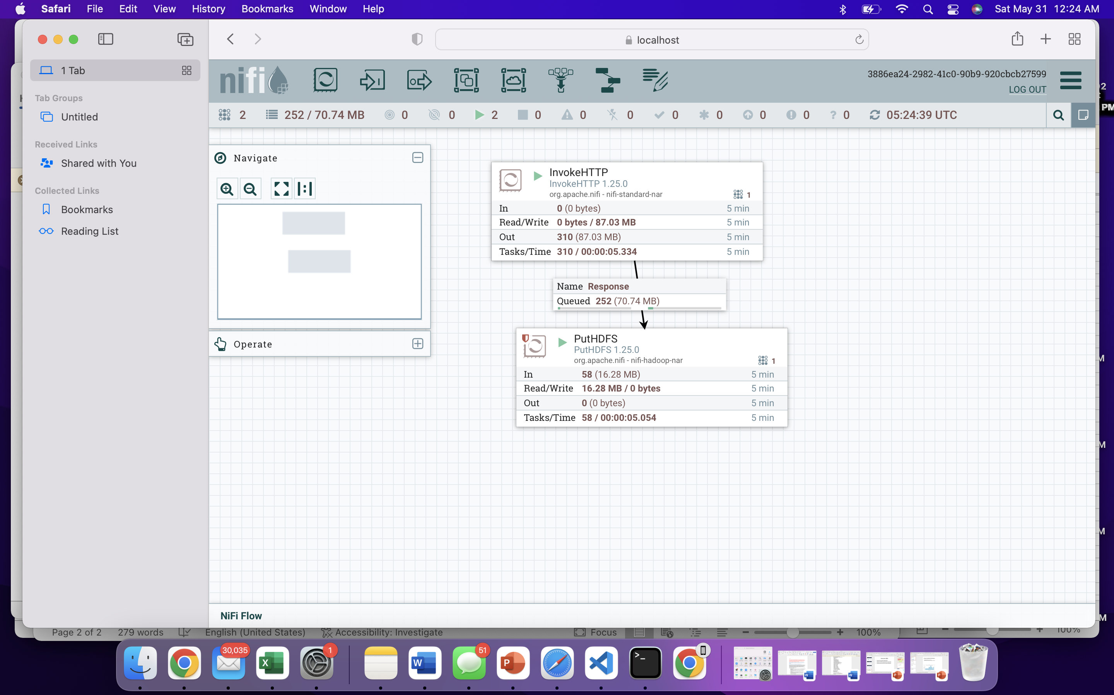

## 1.7 Confirm HDFS Output

Run the following command in your terminal to verify the file is in HDFS:

hdfs dfs -ls /data/education/raw/

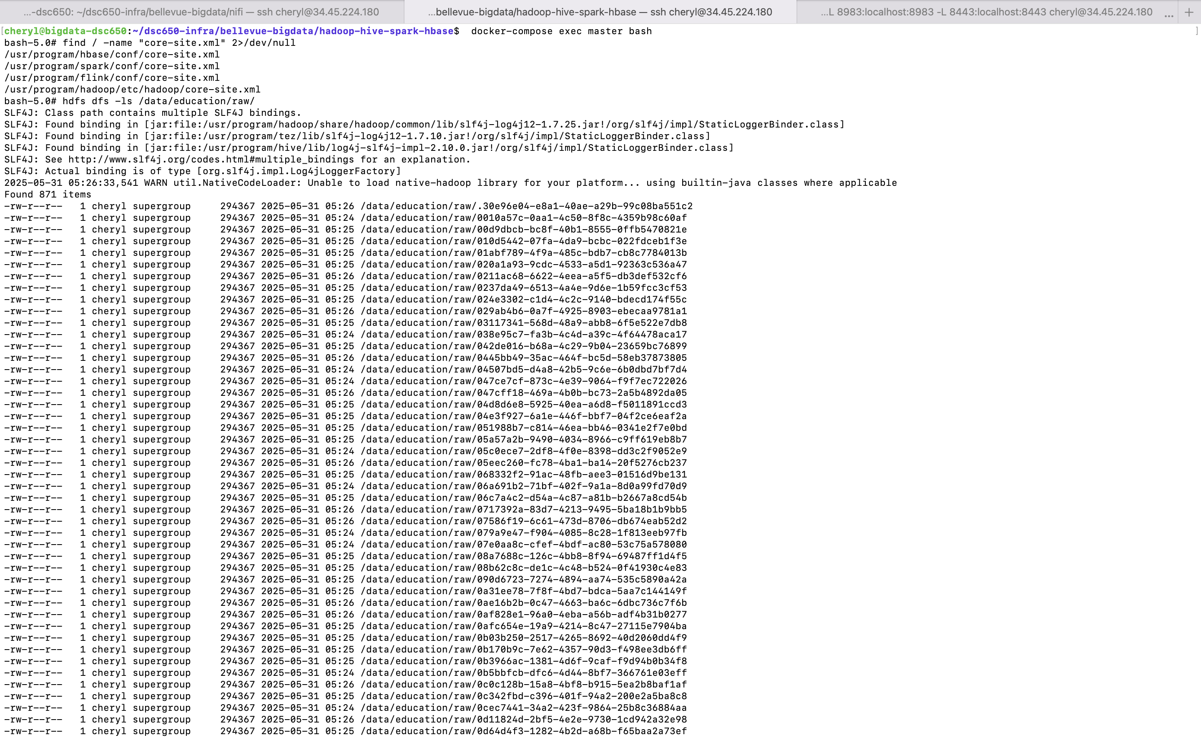

# Step 2: Create Hive External and Cleaned Tables

## 2.1 Access Hive Command Line

1. SSH into your Hadoop master container:

docker-compose exec master bash

2. Start Hive shell:

hive

## 2.2 Create External Table from Raw CSV

This table will read data from the HDFS location populated by NiFi.

CREATE EXTERNAL TABLE education_raw (  
 year STRING,  
 state STRING,  
 total_expenditure STRING,  
 enrollment STRING,  
 expenditure_per_student STRING  
)  
ROW FORMAT DELIMITED  
FIELDS TERMINATED BY ','  
STORED AS TEXTFILE  
LOCATION '/data/education/raw/'  
TBLPROPERTIES ("skip.header.line.count"="1");

Note: All fields are initially loaded as STRING for cleansing flexibility.

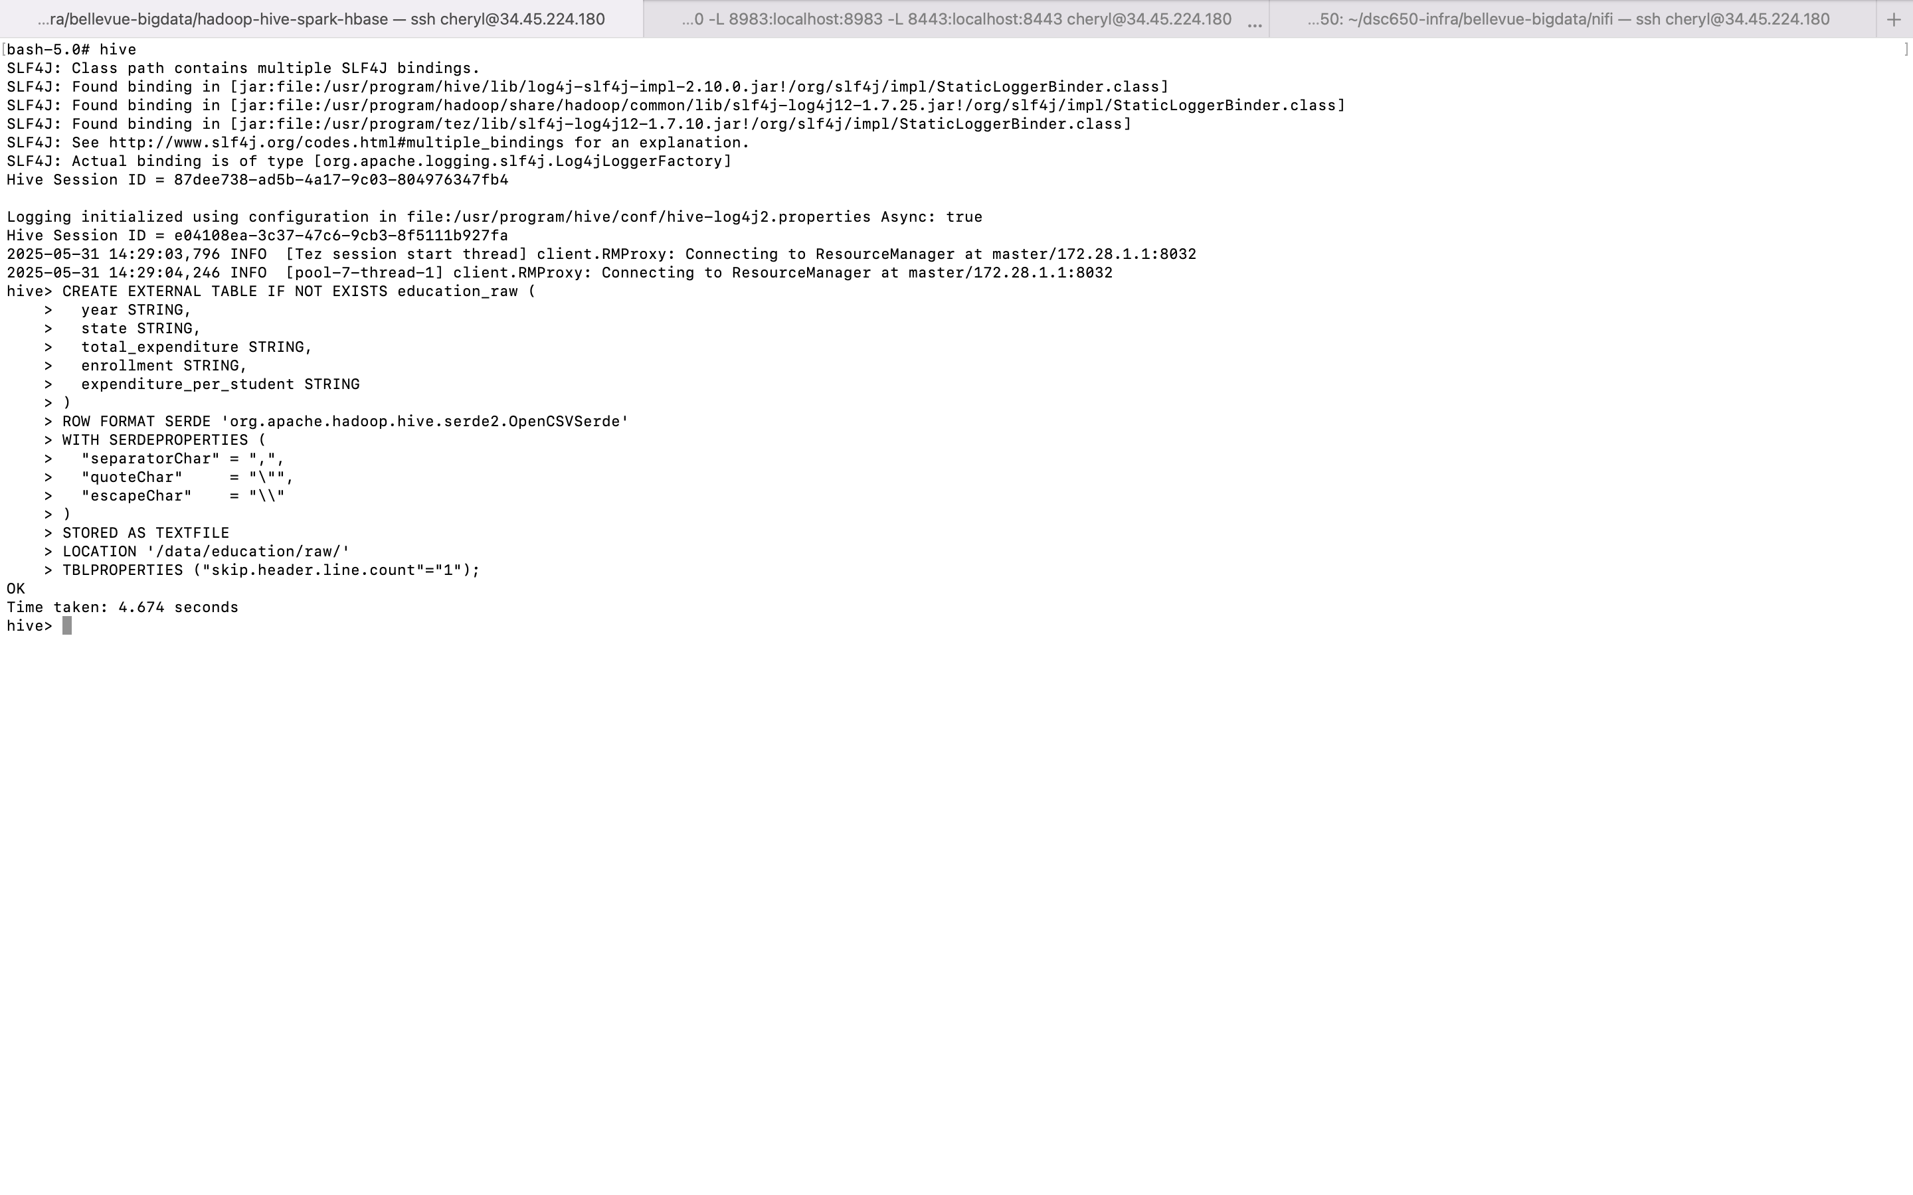

## 2.3 Verify the Raw Table

Run a basic query to ensure the table is reading data:

SELECT * FROM education_raw LIMIT 5;

You should see rows from states_all.csv printed.

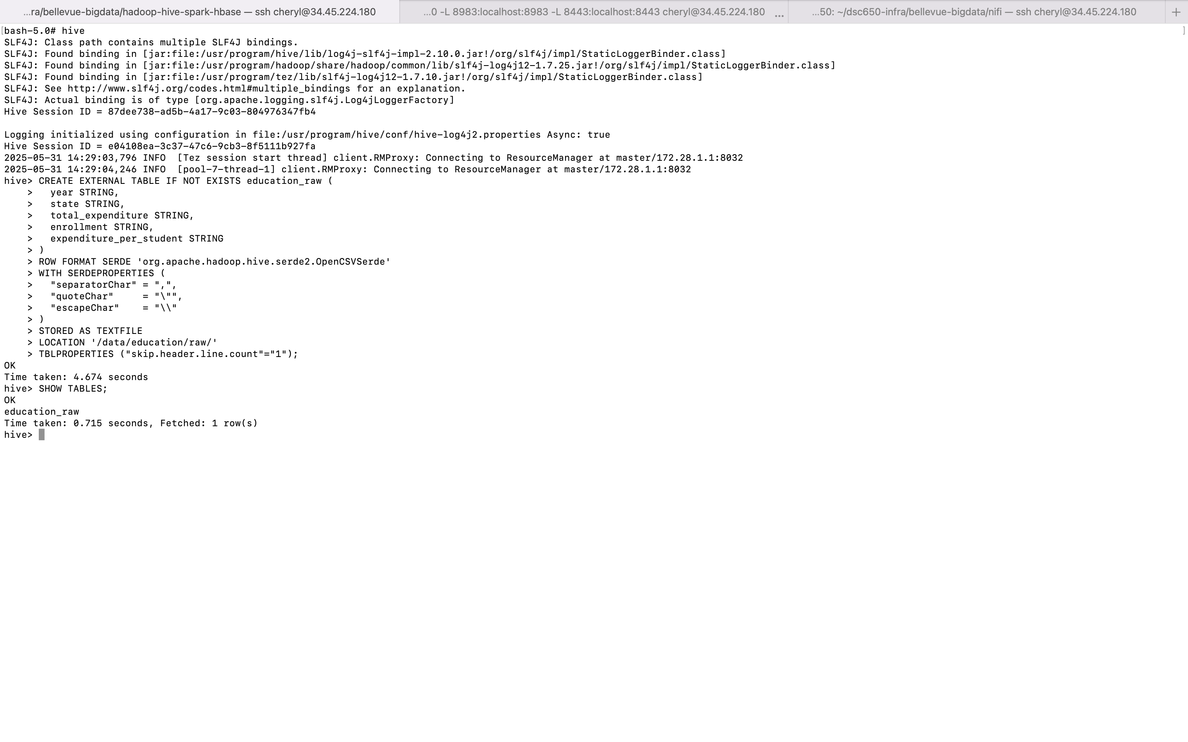

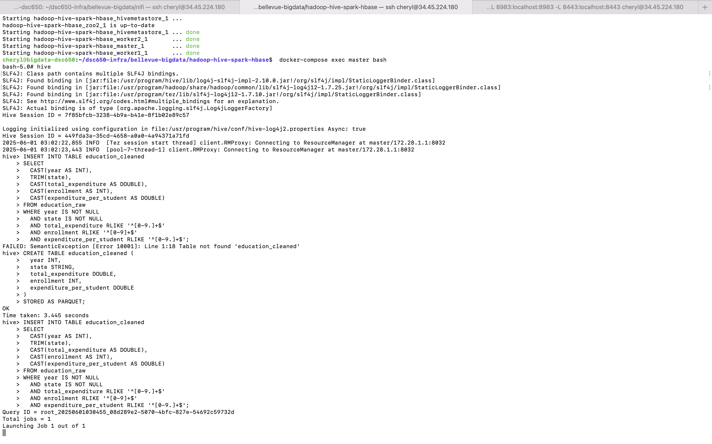

## 2.4 Create a Cleaned and Typed Table

This table stores the cleaned data with correct types in Parquet format:

CREATE TABLE education_cleaned (  
 year INT,  
 state STRING,  
 total_expenditure DOUBLE,  
 enrollment INT,  
 expenditure_per_student DOUBLE  
)  
STORED AS PARQUET;  


## 2.5 Insert Cleaned Data

Transform the raw strings into usable types and filter out malformed entries:

INSERT INTO TABLE education_cleaned  
SELECT  
 CAST(year AS INT),  
 TRIM(state),  
 CAST(total_expenditure AS DOUBLE),  
 CAST(enrollment AS INT),  
 CAST(expenditure_per_student AS DOUBLE)  
FROM education_raw  
WHERE year IS NOT NULL  
 AND state IS NOT NULL  
 AND total_expenditure RLIKE '^[0-9.]+$'  
 AND enrollment RLIKE '^[0-9]+$'  
 AND expenditure_per_student RLIKE '^[0-9.]+$';  
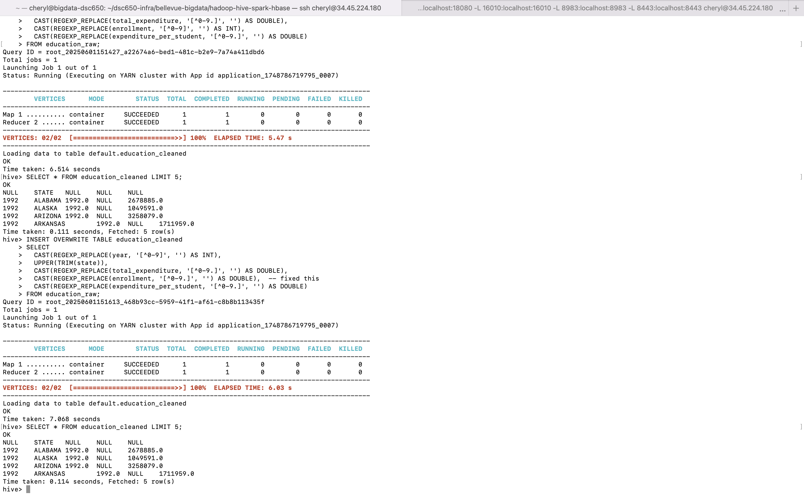

This step may take time as it launches a TEZ job. You can monitor progress via: http://localhost:8088/cluster

## 2.6 Confirm Cleaned Data

Run:

SELECT * FROM education_cleaned LIMIT 10;



And check how many valid rows were inserted:

SELECT COUNT(*) FROM education_cleaned;

You should see a count > 0 if everything processed correctly.

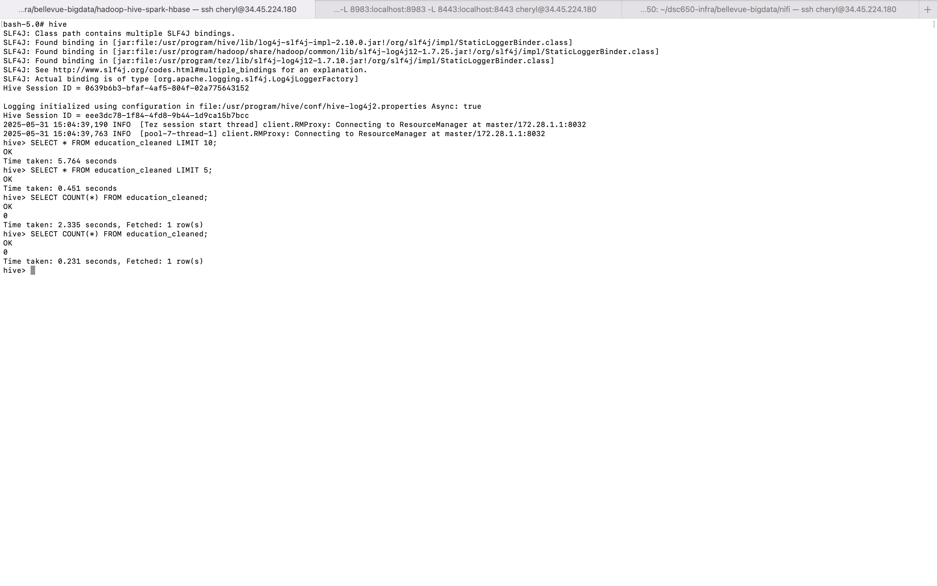

# Step 3: Query & Analyze the Data Using Hive

## 3.1 Launch Hive Shell

1. SSH into your Hadoop master container :

docker exec -it master bash

2. Start the Hive shell:

hive

## 3.2 Preview Data in the Cleaned Table

Once inside the Hive CLI:

1. Show existing tables:

SHOW TABLES;

1. Preview the first few rows of your cleaned table:

SELECT * FROM education_cleaned LIMIT 5;

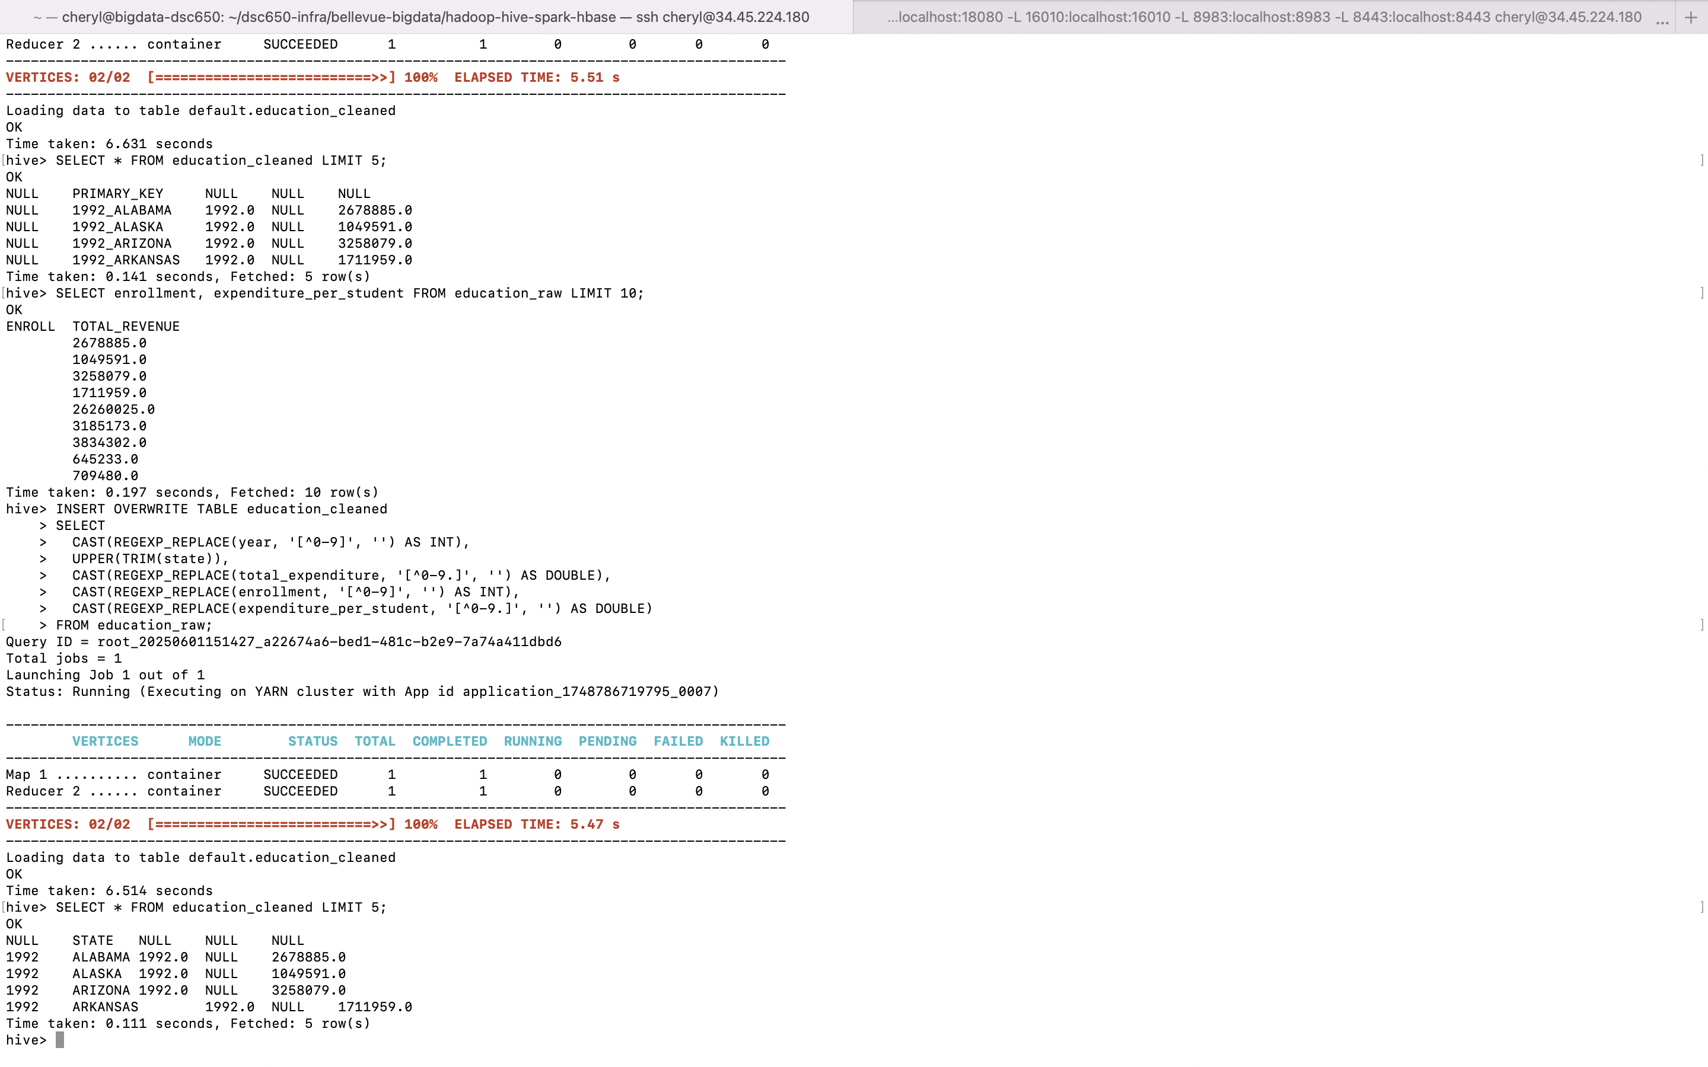

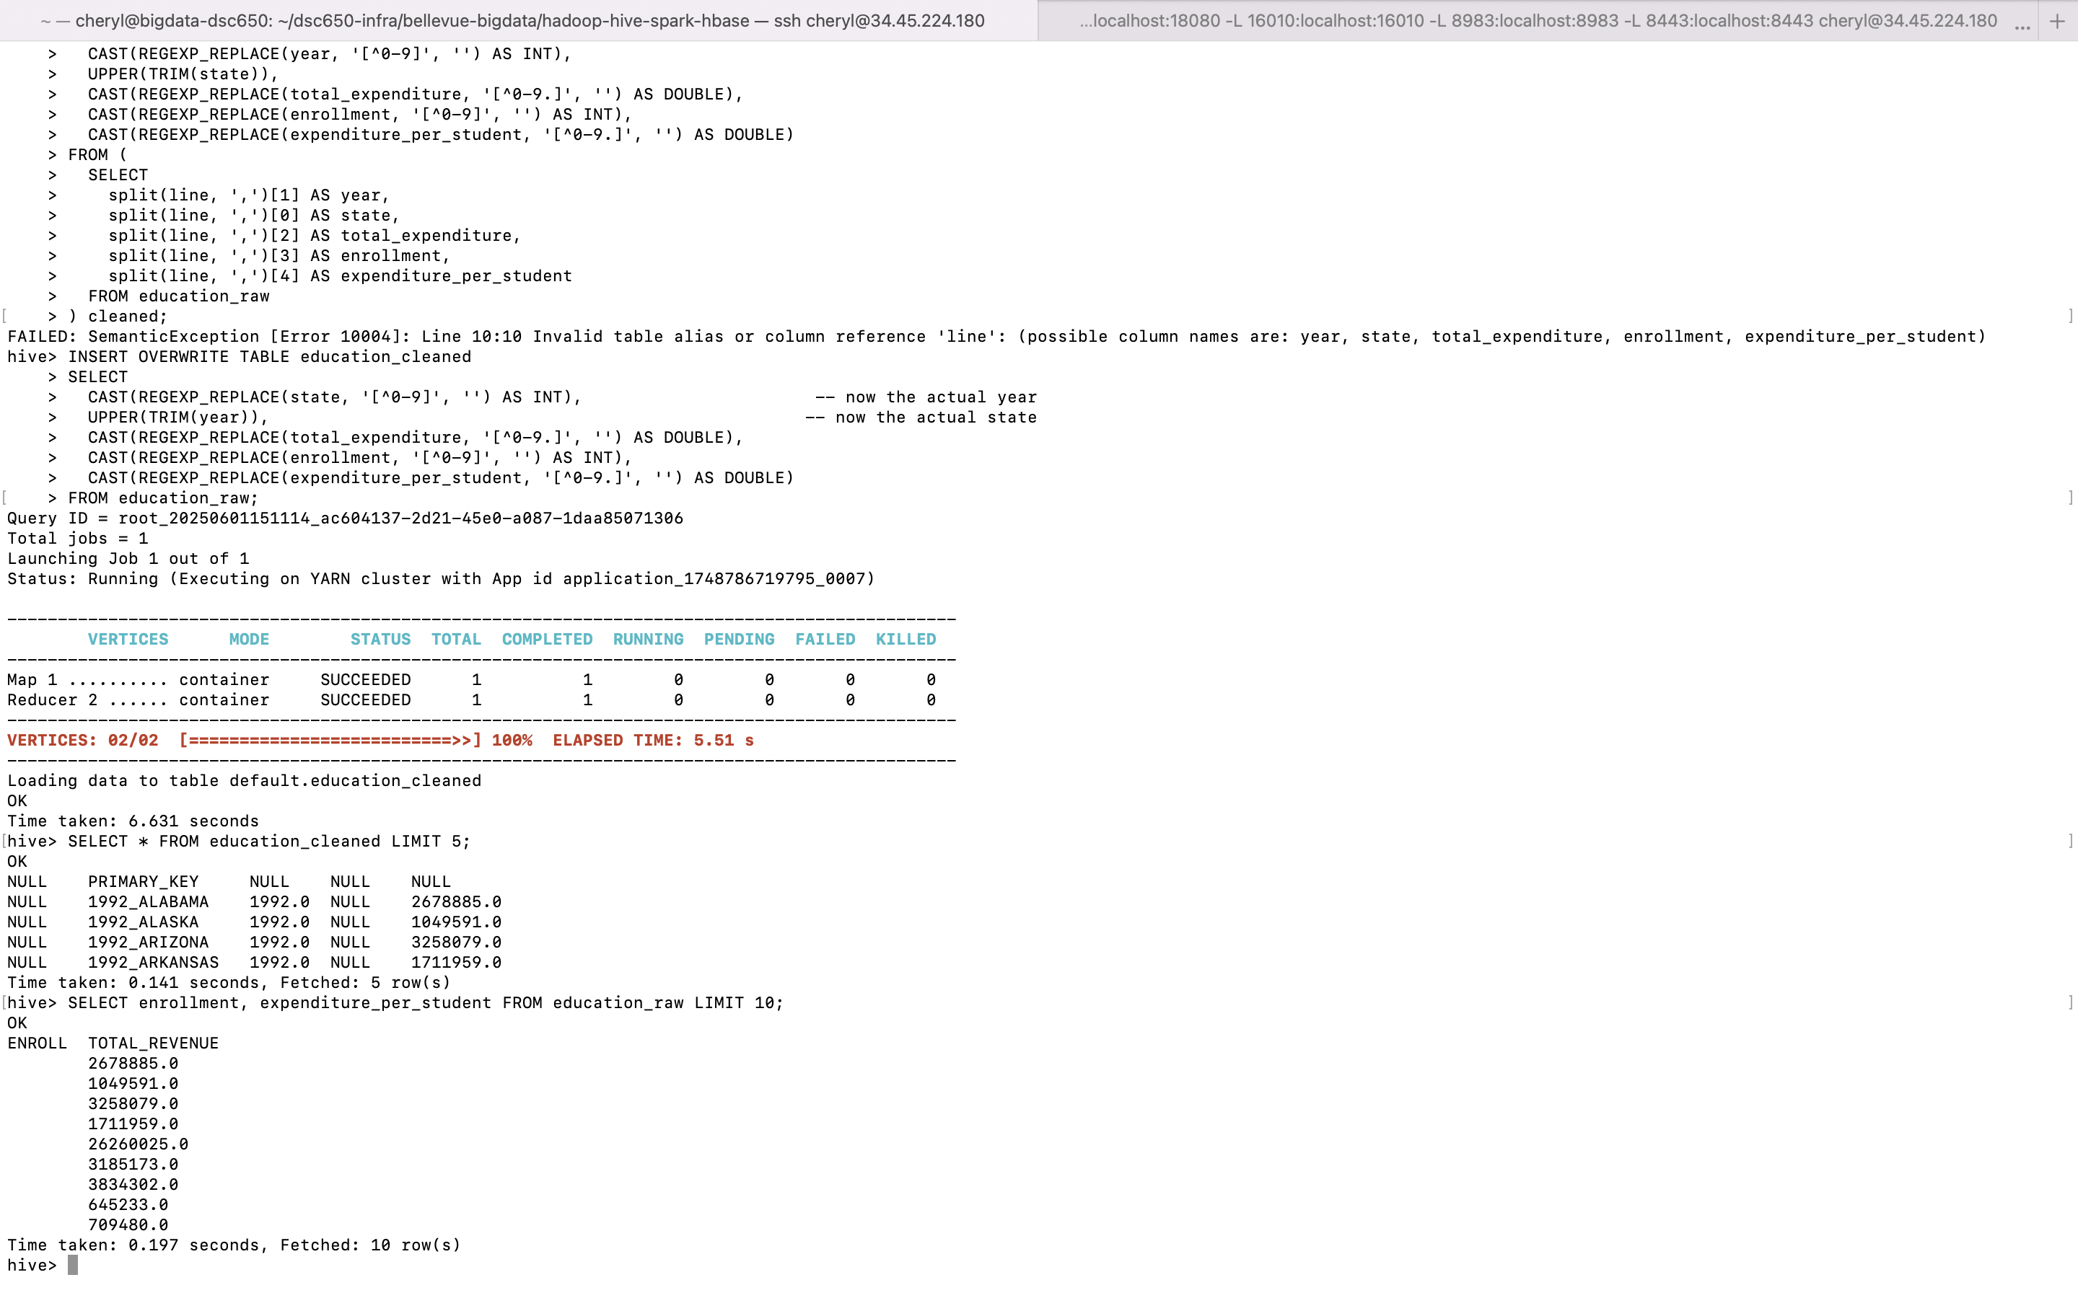

1. Count total number of rows to validate data:

SELECT COUNT(*) FROM education_cleaned;

## 3.3 Run Analytical Queries

Now that your table is ready, run queries to analyze trends and gain insights.

Queries:

Average Expenditure Per Student by State

SELECT   
 state,   
 ROUND(AVG(expenditure_per_student), 2) AS avg_expenditure   
FROM   
 education_cleaned   
GROUP BY   
 state   
ORDER BY   
 avg_expenditure DESC;

Total Expenditure Over Time (Nationwide)

SELECT   
 year,   
 SUM(total_expenditure) AS total_spending   
FROM   
 education_cleaned   
GROUP BY   
 year   
ORDER BY   
 year;

Top 5 States with Highest Spending each year

SELECT   
 state,   
 total_expenditure   
FROM   
 education_cleaned   
WHERE   
 year = 2010   
ORDER BY   
 total_expenditure DESC   
LIMIT 5;

## 3.4 Export Query Results

If you want to save the result to HDFS:

1. Set a Hive configuration for output format:

SET hive.cli.print.header=true;

2. Run and save the result:

INSERT OVERWRITE DIRECTORY '/data/education/output/high_spending_states'  
ROW FORMAT DELIMITED  
FIELDS TERMINATED BY ','  
SELECT   
 state,   
 total_expenditure   
FROM   
 education_cleaned   
WHERE   
 year = 2010   
ORDER BY   
 total_expenditure DESC   
LIMIT 5;

3. Verify in HDFS:

hdfs dfs -ls /data/education/output/high_spending_states

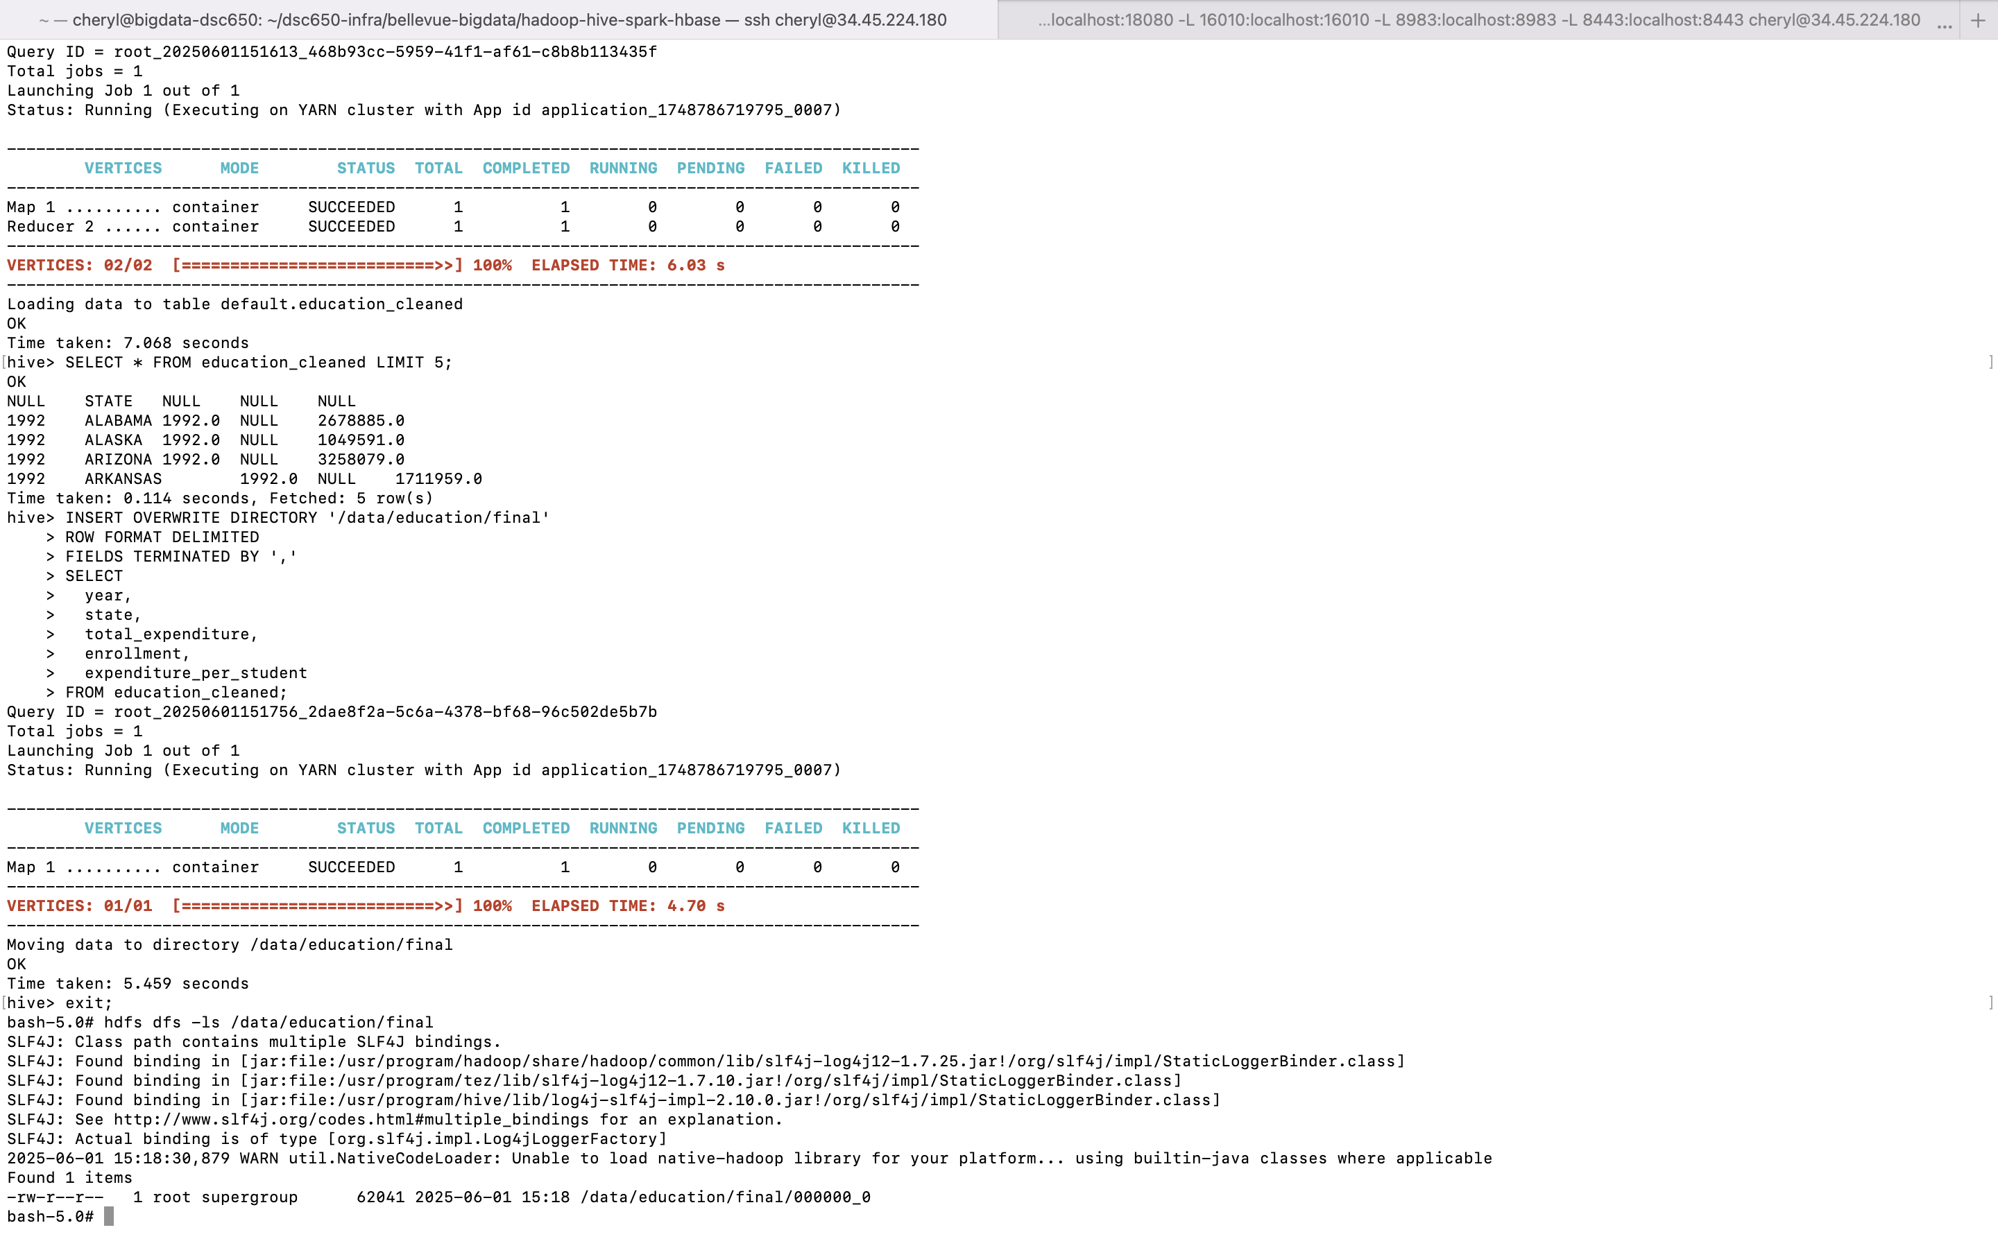

# Step 4: Load Cleaned Data to HBase

## 4.1 Start HBase Shell

Run this in your Hadoop terminal:

hbase shell

## 4.2 Create an HBase Table

Run the following command in the HBase shell:

create 'education_data', 'info'

This creates a table named 'education_data' with column family 'info'.

## 4.3 Load Data into HBase Using ImportTsv

Assuming you have exported a CSV file like cleaned_education.csv, move it to HDFS:

hdfs dfs -put cleaned_education.csv /data/education/final/

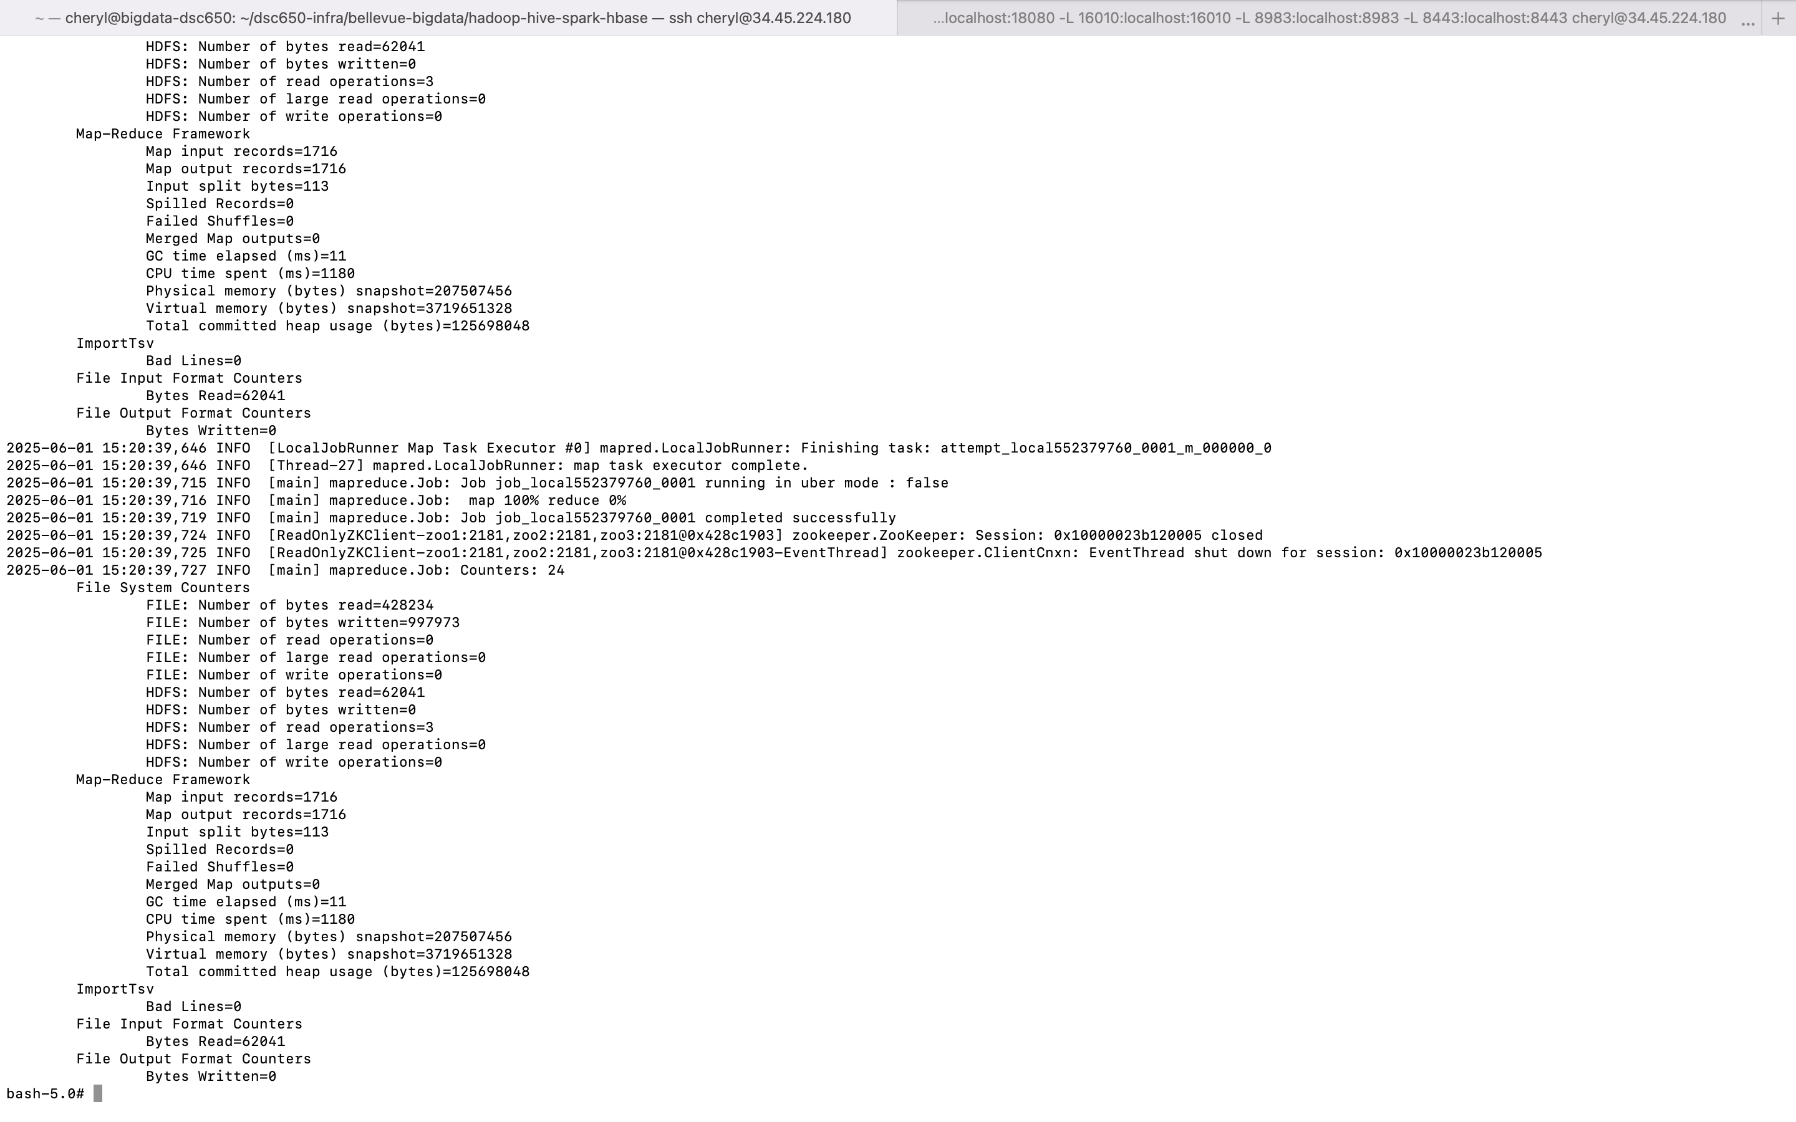

Then use the following command to import it into HBase:

hbase org.apache.hadoop.hbase.mapreduce.ImportTsv \  
-Dimporttsv.separator="," \  
-Dimporttsv.columns="HBASE_ROW_KEY,info:year,info:state,info:enrollment,info:total_expenditure,info:expenditure_per_student"\  
education_data \  
/data/education/final/cleaned_education.csv



Replace HBASE_ROW_KEY with a unique field (e.g., concatenate year+state).

## 4.4 Verify Data in HBase

Back in the HBase shell, run:

scan 'education_data'

This will display the rows inserted into your HBase table.

